Functional electronic circuits Lab1

Student Name: CAO Xinyang

Student ID: 20321308

The picture with microarchitecture:

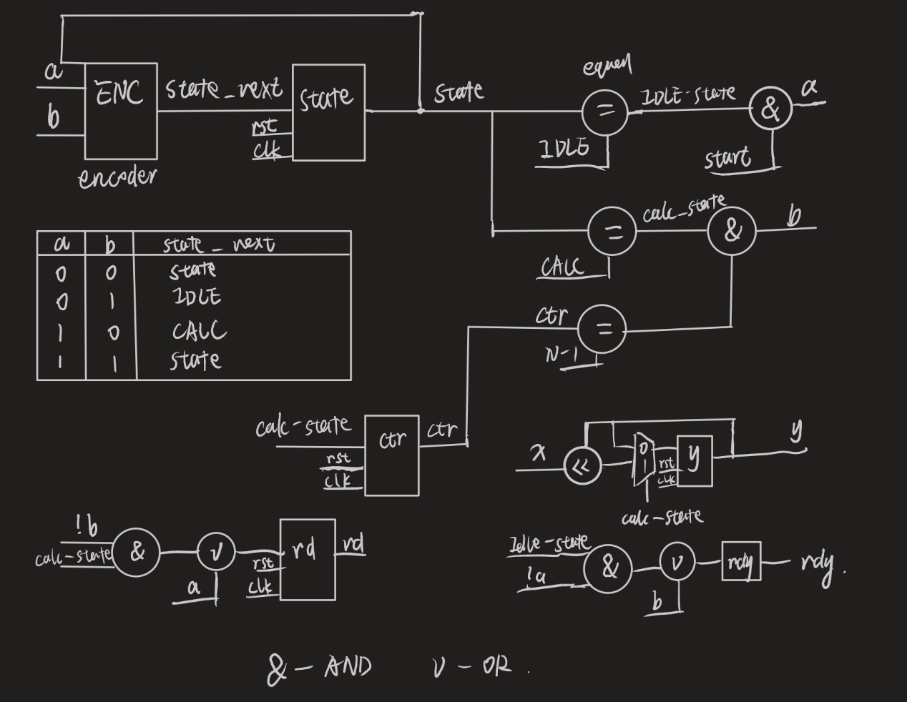

The timing diagram with simulation results:

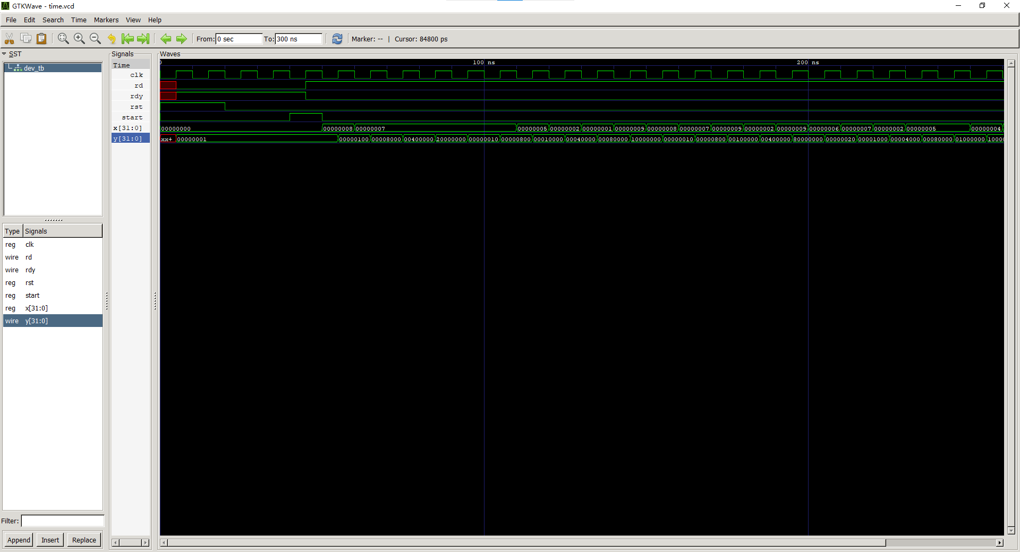

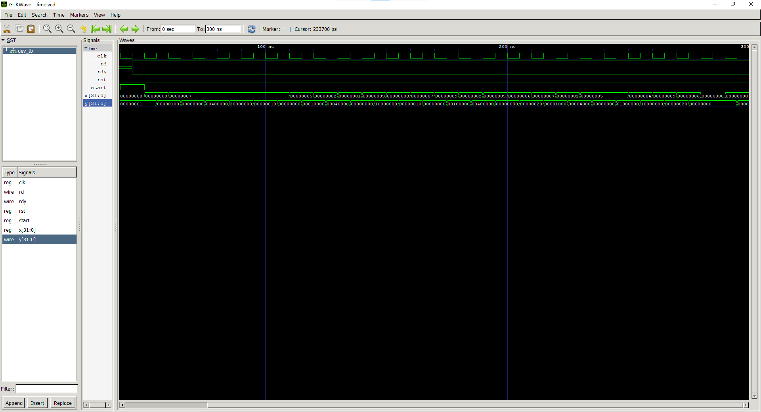

Code of the testbench and the device:

***dev.v***

module dev(

    input [31:0] x,

    input start,

    input rst,

    input clk,

    output reg rd,

    output reg [31:0] y,

    output reg rdy

);

parameter N= 10;

parameter IDLE = 0;

parameter CALC = 1;

reg state;

reg[2:0] ctr;

always@(posedge clk)

    if(rst) begin

        state <= IDLE;

        ctr <= 0;

        rdy <= 1;

        rd <= 0;

        y <= 1;

    end else begin

        case(state)

            IDLE:

                if(start) begin

                    state <= CALC;

                    rdy <= 0;

                    rd <= 1;

                end

            CALC:

                begin

            ctr <= ctr + 1;

                y<=(y << x) | (y >> (32 - x));

         if(ctr == (N-1))begin

                  rd <= 0;

              state <= IDLE;

              rdy = 1;

         end

         end

            endcase

        end

endmodule

***dev_tb.v***

`timescale 1ns/1ps

module dev_tb;

reg [31:0] x;

reg start,rst,clk;

wire rd, rdy;

wire [31:0] y;

dev uut(

    .x(x),

    .rd(rd),

    .start(start),

    .rst(rst),

    .clk(clk),

    .y(y),

    .rdy(rdy)

);

always #5 clk = ~clk; // each 5 ns we will get opposite value of clk sigr

always@(negedge clk)

    if(rd)

        x = ($random % 10) & 8'hFF;

initial begin

    $dumpfile("time.vcd");

    $dumpvars(1, dev_tb);

    clk = 0;

    rst = 1;

    start = 0;

    x = 0;

    #20

    rst = 0;

    #20

    start = 1;

    #10

    start = 0;

    #250

    $finish;

end

endmodule